Purpose: to quantify calcium flux upon T cell activation.
Note: Started from Ca++ flux protocol from “Liu et al. “T Cell Receptor–initiated Calcium Release Is Uncoupled from Capacitative Calcium Entry in Itk-deficient T Cells” J. Exp. Med. 1998, and modified from this starting protocol.
- Start from activated, transduced cells that spent at least 2 days in culture after transduction
- Collect cells from same condition/congenic marker together and count them – mix cells 1:1
- From here split cells in one tube for each stim condition you have below at step 11.
- Stain 1.0-1.2x10^6 total cells per stim/tube with 50 nM X-Rhod-1 AM (1:25,000; Molecular Probes) and 0.02% Pluronic F-127 (1:100; Invitrogen) in HBSS-/- for 30 minutes at 37ºC with gentle agitation (pipette every 10 minutes). Stain samples in 300 µL. Always make 1 tube extra when preparing the mix. Optional: Keep unstained cells for later.
- Wash 1 time with HBS; resuspend cells at 1x10^6 /mL with R10 and incubate for 45 minutes at 37ºC.
- Incubate cells with anti-CD3-biotin (final: 10 µg/ml; 1:50 dilution form stock), anti-CD45.1-APC or anti-CD45.2-APC (1:200 dilution from stock) and Thy1.2-FITC (1:1,000 dilution from stock) in PBS for 20 mins at RT. Stain samples in 100 µL. Always consider 1 tube extra when preparing the mix.
- Wash 3 times with HBS; resuspend at 1x10^6 /mL with R10 and keep at 37ºC until ready to use
- When ready for acquisition spin cells down 1600 rpm for 5 minutes, resuspend as indicated in step 9 and transfer to FACS tubes. Each condition/tube you run wants 1.0-1.2x10^6 cells total.
- When running your experiment on the Fortessa, cells will be run in 300uL HBSS with 0.5mM Ca++ (for stim a) or 300uL plain HBSS (for stim b & c), so stim conditions will be made at 10x concentrations in 10% of the volume (30uL):
  - Streptavidin (SA): final 40 µg/ml, make 10x (30 µL) [dilute stock 1:2.3, get 30µL from dilution]
  - Ionomycin: final concentration of 1 µg/mL, make 10x (30 µL) [dilute stock 1:100, get 30µL from dilution]
  - Ca++: final 0.5 mM, make 10x (30uL) [dilute stock 1:10, get 30µL from dilution]
  - TG: final 2 µM, make 10x (30 µL)
    - For stim b = dilute stock 1:100, get 30µL from dilution
    - For stim c = add 0.4 µL stock to 30 µL of stock Ryanodin
  - Xestospongin C: final 1 µM, make 10x (30 µL) [add 3.3 µL stock to 30 µL of stock TG+Ryanodin]
  - Ryanodin: final 100 µM, stock is already 10x – just add 30 µL from stock to sample when ready
  - EGTA: final 3 mM, stock is already 10x – just add 30 µL from stock to sample when ready
- Wash cells, resuspend in 300uL HBSS with 0.5mM Ca++ (for stim a) or 300uL plain HBSS (for stim b), and set up Fortessa. Make sure to have unstained control for calcium flux dyes. X-rhod-1 AM (in PE-CF594 channel) gets brighter when binds to calcium, so set negative on unstained control.
- Have stim conditions listed below; each sample gets run for minutes indicated below:
  - 30sec baseline, +Ionomycin 5min
  - 30sec baseline, +TG 3mins, +Ca++ 2mins, +EGTA 3min
  - 30sec baseline, +TG/Ryanodin/Xestospongin 3mins, +Ca++ 2mins, +EGTA 3min
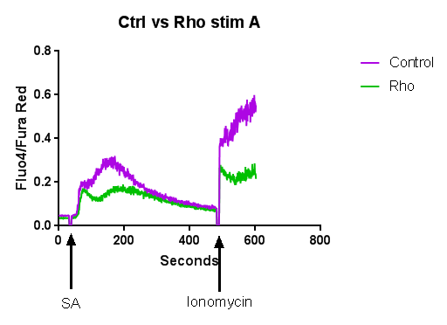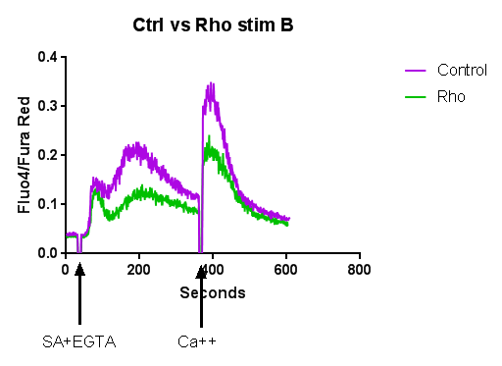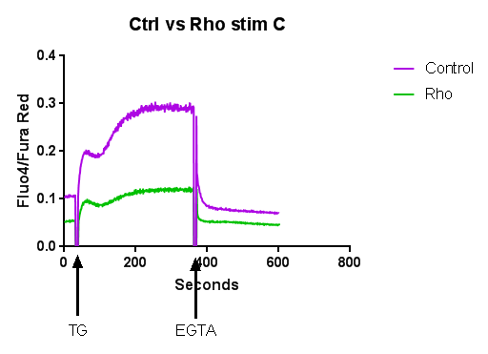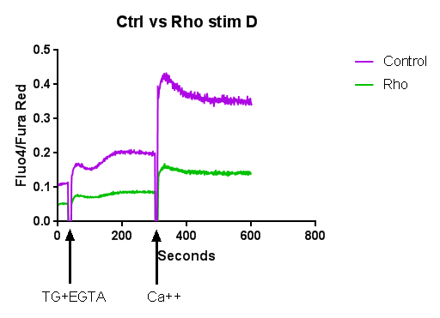

2X HEPES buffered saline solution (500 mL)

274 mM NaCl 8 g
10 mM KCl 350 mg
1.4 mM Na2HPO4 100 mg
15 mM D-glucose 1.35 g
42 mM Hepes 21 mL (stock 1 M)

Check pH at 7.05
Filter with 0.22 µM
Aliquot 50 mL conical tubes
Freeze at -20 ºC (stable for 1 year)

